Data Programme
Data Architecture Blueprint
May 2023

Version 1.5
Document Control
Review
Reviewed by | Date

Document History
Version | Summary of Changes | Date Published
1.4 | Draft

Approval
Approver | Title | Date
Tom Webster | Head of Data
Alex Bilas | Chief Data Officer

Contents
Objective of a Data Architecture Function 4
Data Architecture 5
Vision 5
Current State Review 6
Gap Analysis & Considered Options 7
Strategic Solution Objectives 9
Insights Platform Data Architecture 11
Conceptual Architecture 11
Target Data Architecture 12
Component Overview 14
Data Architecture Process 15
Key Systems 16
Data Lake Storage 17
Data Lake Zones 18
Role of Each layer In Data Platform 19
Data Movement 20
ETL Phases 21
High Level Design – EventHub to Raw DLT 22
Data Flow without CDC from Source to RAW 22
Data Flow with CDC from Source to RAW 23
Raw to Standardised 23
Without CDC from Raw to Standardised 24
With CDC from Raw to Standardised 25
Standardised to Conformed 25
Conformed to Staging 27
Staging to DW 27
Data Integration 29
Integrating new system / Data into New data platform 30

Objective of a Data Architecture Function
The overall Data Architecture objective is to ensure that data and technology supporting data continues to satisfy the needs of Canopius into the future.

This objective is enabled by a data architecture function through the design, development, and maintenance of a comprehensive and cohesive data architecture that supports an organization's business objectives and information needs. This involves defining the various types of data that an organization uses, the relationships between different types of data, and the rules and standards for how data is collected, stored, processed, and shared.

A well-designed data architecture enables an organization to effectively manage its data assets, ensure data quality and consistency, enable efficient data processing, and facilitate data integration across different systems and applications. It also provides a framework for making strategic data-related decisions, such as determining which data sources to use or how to structure data for analysis.

The data architecture function guides the organisation to establish a solid foundation for its data management practices which can ultimately help drive business growth and success.

Data Architecture

Vision
Key principles taken into consideration when proposing the new architectural solution for the Canopius Data Platform:
- All reporting will be produced from a single data platform and there should be no requests to source applications.
- This platform should include only relevant data for either reporting or processing and not a complete copy of the source systems.
- History (where available – either directly or via existing data warehouses) should be imported and retained in the platform.
- The platform should perform refresh/update operations with minimal manual intervention. Monitoring and alerting should be implemented.
- Reports, both business and regulatory should be able to be produced entirely from the platform, without any processing outside it.
- Code development, deployment and testing for new releases will use agile methodology and Continuous Integration/Continuous Delivery (CI/CD) pipelines using a shared code repository.
- Data storage, movement and transformation will follow data quality controls, data/security/regulatory standards and audit requirements.
- New releases of the data platform should be phased to provision additional data, with minimum disruption on business.
- Business users should get self-service BI capabilities, backed up by proper data glossary, presenting business terms to users and hiding the physical representation of them.
- All the metadata defining data transformations will be stored in a repository to enable production of data lineage across entire data journey (from source to report).
- Cloud technologies will enable data scope to include all regional Canopius entities.
- Unstructured or semi-structured data added to the data platform will be subject to the same access rules as for structured data.
- Data ingestion into the data platform will be governed by Data Architecture principles in the Data Architecture PMS.
- Information data retention policies will enable data to be automatically moved between three different storage tiers, Hot, Cool and Archive. These will reflect the requirements from the Data Governance and Quality framework impacting Metadata (data catalog, data lineage).

Current State Review
Current Data Landscape Analysis

- Understand sources which are directly feeding to Data warehouse (RED & Graft)
- Reverse engineer the Data Models from the DWH and understand how the data is structured
- Understand how data is Extracted, Transformed and loaded from operational sources to Data DWH.
- Understand how data is moved in between RED and Graft
- Understand the number of applications that consume the data from DWH and serve the data to different business functions
- Understand all the applications that are feeding data to the sources and to the business processes that will show some end – to – end lineage.
- Understand database technologies and their versions to support data integration
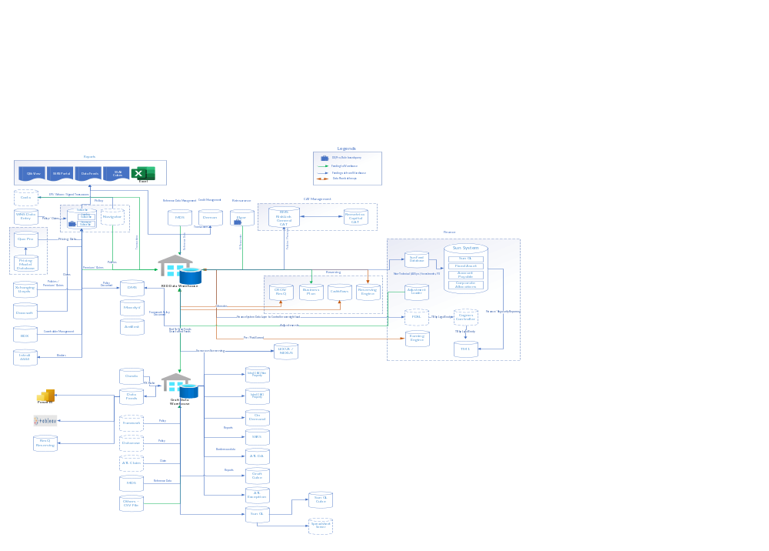

Gap Analysis & Considered Options
- Different businesses and downstream functions use different reference data, and models/definitions for data
- The data moves between RED and Graft data warehouses, resulting in a high degree of duplication, with impact on storage and increasing the complexity of business processing.
- Data flows separately via individual point-to-point feeds to each downstream function – no single version of truth
- Canopius currently maintains two separate data models inside the two RED and GrAFT Data Warehouses.
- Finance, Risk, Actuarial, Product each need to transform, complete, correct, and enrich the data via complex rules to support their processing
- Regulators receive reports & data from multiple functions, Risk & Finance, which can be inconsistent and inaccurate
- Data Governance not defined at enterprise level Data Quality & Change management process not defined at source level
- Canopius has many discrete projects/activities running in parallel, which are actively exploring data quality, metadata, and other data management functions
The analysed options were:

- Combining the flows and data warehouses into RED
- Combining the flows and data warehouses into Graft
- Combining them to a best-of-both-worlds output
- Strategic solution in cloud
Combining to RED

The main advantage for this approach is that the existing applications and reporting continue to be used. Subscribe was already selected as policy administration unified platform, and the flows to Subscribe would not have to be recreated. Reports can still be used from MIDAS, which make this approach the best in terms of amount of rework.
Although presented as an advantage for remaining on RED, all QlikView implementation is also a disadvantage. Qlik also recommends shifting from QlikView to QlikSense so that business users would use the tool also for analysis and discovery, rather from exporting the data and do the analysis in Excel.
Drawbacks for this approach are coming from the list of findings, where most important being the way data is consumed from RED. The way consumption works makes GrAFT a better choice and enabling more business users to consume the data directly in the format they need. Another gap to cover if combining to RED would be operational Reinsurance data, that needs to be included in RED. The Actuarial and Finance engines in GrAFT should also be redeveloped on top of RED data model.
The other disadvantages are coming from design, where GrAFT implements a newer set of best practices and being able to accommodate business data more efficient.
The release process for RED is not being actual and needs a refresh to follow industry trends.

Combining to Graft

The main advantage for this approach is the Graft architecture, easily scalable, with strong data rules and frameworks around. The CI/ CD pipelines already implemented in Azure DevOps are simplifying adoption of cloud.
In terms of onboarding new syndicates and being able to support more business functions, Graft’s architecture is also an advantage.
Rulebook earning engine in Graft has been mentioned in the interviews as more efficient.
The disadvantages reside in integration with Subscribe and how business users will shift from current reporting to Graft way of producing reports. The latter can also be considered an advantage in a way, because reporting in Graft world is done only from the DWH and not merging any date from other sources (additional information from source systems, or other places).
The amount of work and potential issues are residing from migrating Finance and Actuarial feeds for Syndicate 4444, integration with the existing MDS for Syndicate 4444 and rework of the entire set of reports provided by MIDAS / QlikView.

Combining to best-of-both worlds

Strategically, this is the best approach, with the disclaimer that is not covering future data sources but covers only existing issues. It would allow creation of the target architecture without affecting existing flows in the first phases, then building the clones and history in cloud without provisioning extensive hardware and being able to tune the processes with the elastic cloud resources in order to meet the performance requirements.
In terms of effort, this might be substantially higher than keeping any of the data warehouses. It should start with reviewing the data models, an exercise that already started in Canopius, and choosing the best way to store the data. The exercise already started and data from 2019 was used for testing.
Reporting and preparing the data for consumption are also more flexible in GrAFT and are a good starting point, since data is presented with business.

Strategic solution in cloud

In any of the previous approaches, there are several data flow changes to be made. This involve storing duplicate data, managing new databases and/ or database servers, together with administration.

On top of best-of-both-worlds approach, migrating them in cloud is bringing elasticity, information lifecycle management, data retention with proper tiers and costs, availability for new semi-structured and unstructured sources.

Migration to cloud has advantages in this area, offering the capability to build this centralized database out of the current hardware and on-premise architecture.

Strategic Solution Objectives
Objective | How it will be achieved
1. A single version of the truth for reporting and analysis | Centralized repository will be built in Azure based on RED / Graft. Data will get loaded daily, there should be no requests to source applications. The platform should include only relevant data. History should be imported into Platform.
1.1. Structured data from all Canopius entities including | All data from existing entities is planned to be loaded
1.2. Structured data from all business functions | Data from analysed applications (Subscribe , Elgar, Intrali, MDS) is planned to be loaded
1.3. Structured data from third parties | Data from third parties is planned to be loaded
1.4. Centralised reference data management | Data from existing MDS solutions is planned to be loaded and extended with future entities
1.5. Centralised data checks and controls | Ingestion framework would include checks, controls, alerts and error reporting and recycling
1.6. Unstructured data formats | Unstructured data is also in scope and will be loaded near the structured data within Data Lake. Further transformation so that it can be integrated are required.
2. A common reporting portal for the entire business | The reporting portal is the end goal, but migrating all existing reports and building new ones will be phased
2.1. All data must be accessible via this portal
2.2. Reports should not create data of their own; all required fields must exist in upstream layers
2.3. Tools must be flexible to enable end users to perform custom analyses, whilst being restricted enough to meet the IT audit requirements and avoid shadow IT
3. A common set of analytical models for the entire business | Having all the required data in a single place is enabling development of analytical models with ready-to-use technologies available in the selected cloud platform
3.1. Earnings
3.2. What-if scenarios
3.3. Predictive analysis
3.4. Etc.
4. A scalable platform to support accelerated onboarding of new acquisitions | By having the Data Dictionary and Data Catalogue in place, onboarding process is simplified and require mapping the new entity to existing data Dictionary, ingest the new data and its history and transform it to the final model
4.1. Generic insurance data model for both Lloyd’s and non-Lloyd’s entities
4.2. Full coverage including bordereaux, exposure management, Actuarial, Finance, etc.
5. Elimination of manual processes relating to | The ingestion framework, together with CI/CD pipelines will minimize the need for manual processing
5.1. Data gathering | Ingestion framework will be able to deal with a variety of sources and ingestion types
5.2. Data transform | Data transformation is part of the ETL flow, and some transformation require development, but one-off and then it will run automatically
5.3. Data analysis | Many data attributes and quality checks will be automatically included in the ETL flow so that it should also identify issues in loaded data. Complex ones need ETL development
5.4. Regulatory reporting preparation | Regulatory reporting is the first part that should be delivered from the reporting solution
6. Reduce Costs of managing multiple applications | Canopius currently has to support 2 separate data warehouses, associated applications and processes. This is costly to maintain, moving to a single warehouse and set of processes will reduce costs to Canopius and free up the IT teams time enabling them to better support the business.
7. Satisfy regulatory returns accurately, timely and efficiently | Platform contains all of the data that would be needed for regularity returns and it should be readily accessible with high quality of data.
8. Invest in innovative, data driven solutions | Opportunity to invest in innovative, data driven solutions, which leads to reliable enhanced decision making and user experience
9. Improve Canopius technical and analytical capabilities | Improve Canopius technical and analytical capabilities by adopting best in class tool sets and training
10. Adopting data standards, definitions and governance | Support group wide alignment by adopting agreed data standards, definitions and governance
11. Be a data-driven organization | All of the data in data platform is readily available in one place that everyone can access to different use cases, different view of data available in data platform so it can be used for Data science purposes, reporting purposes, history, ETL etc,

Insights Platform Data Architecture
Based on review of the current state, gap analysis to strategic objectives and a review of the current technology landscape, the go-forward data architecture for the strategic Insights Data Platform has been determined. This section provides an overview of this data architecture.

Conceptual Architecture
Below follows the reference architecture from Microsoft, that can be extended further on with, for example, streaming processing and machine learning.

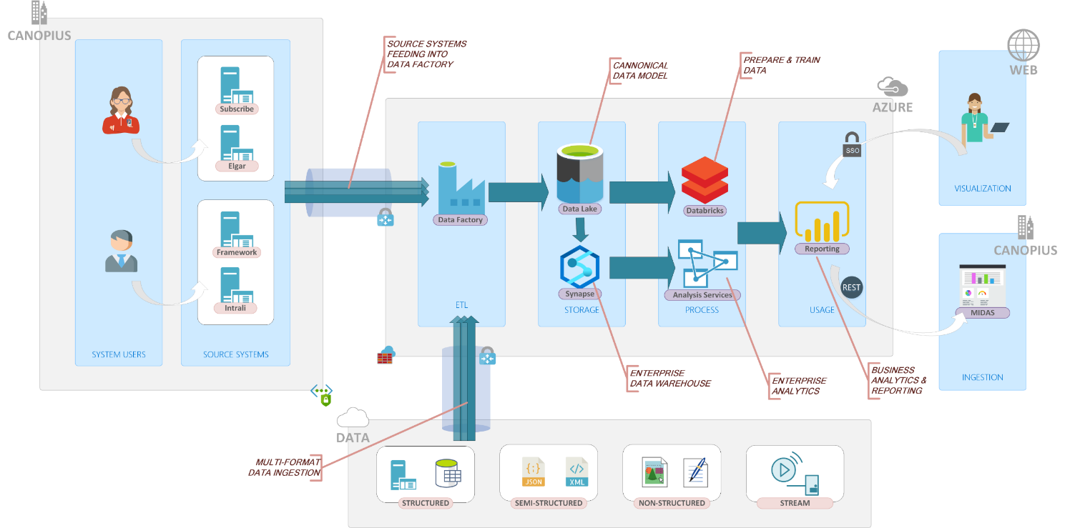

Data should be extracted from existing sources (internal and external systems, together with reference data and departmental data) into a unified location, providing low cost for storing large amounts of data, offering required security, governance, and auditability. This location is a data lake and the proposed solution is Azure Data Lake Storage Gen 2.
CDC tools HVR has been implemented to be able to load data from the source database and continuously capture any changes . HVR creates JSON messages from the change rows, and then posts the message to an Azure Event Hub.
Ingestion process would be scripted and would be able to get data from existing databases, both full or delta loads, from flat files and documents. The main technology for ingestion would be Azure Data Factory.
The data lake will have multiple zones: Raw, Standardised, Conformed and Dimensional. Data can be transformed between the zones with multiple technologies like Data Factory, SSIS, HDInsight, Databricks and Polybase.
The data warehouse will expose the results as data feeds or publish the data via selected reporting and visualization tool (PowerBI).
Fully transformed data in Conformed Zone of data lake will be used to load data into a relational database suitable for analytical processing. The technology for this is Azure Synapse Analytics, former Azure SQL Data Warehouse.
All the above steps should be properly backed-up by metadata and Data Catalog that can keep track of all data sources. Data Catalogue tool is Erwin Data Intelligence Suit.

Target Data Architecture
Creating a To Be data architecture landscape involves designing a future state vision of the organization's data architecture. Here are some principles and guidelines to consider when creating a To Be data architecture landscape:
1. Identify the business requirements: The data architecture should be aligned with the business objectives and goals of the organization. This means that it should be designed to support the organization's strategies, processes, and operations.
2. Define the data architecture vision: The data architecture vision should describe the desired future state of the organization's data architecture. It should outline the key components of the data architecture, including the data sources, data storage, data integration, data analytics, technologies and data governance.
3. Identify the Gaps: A gap analysis in data architecture is an assessment that identifies discrepancies or “gaps” between the current state of a data architecture and its desired state (vision). It is an ongoing process that requires continuous monitoring and evaluation to ensure that the data architecture remains aligned with the organization’s goals and objectives
4. Data governance framework: The data architecture should be built on a foundation of effective data governance practices that enable data quality, accuracy, and security. It should also ensure compliance with relevant regulations and standards.
5. Data integration: The data architecture should facilitate the integration of data from different sources and enable interoperability between different systems and applications.
6. Choose the right technology: Selecting the appropriate technology stack is crucial to building a data architecture that can support the organization's needs. This involves evaluating different technologies and selecting the ones that are best suited to the organization's data requirements.
7. Scalability and Flexibility: The data architecture should be scalable and flexible enough to accommodate changes in the organization's requirements over time. It should be able to handle increasing volumes of data and new data sources without sacrificing performance or data quality.
8. Metadata Management: The data architecture should include a robust metadata management system that captures and manages metadata across the enterprise and data modelling. This ensures that data is properly understood, documented, and used in a consistent and meaningful way.
9. Performance and Scalability: The data architecture should be designed to deliver a high level of performance and scalability. This includes optimizing data access, storage, and processing, as well as ensuring the use of appropriate hardware and software technologies.
10. Usability: The data architecture should be designed to be user-friendly and easily accessible to stakeholders with an appropriate level of need across the organization. This means that data should be presented in a clear, understandable, and actionable format that meets the needs of different users and use cases.
11. Data Quality: The data architecture should prioritize and support sustainable data quality, accuracy, completeness, and consistency. This requires the establishment of data quality controls, data validation, and data profiling.
Overall, creating a To Be data architecture landscape requires careful planning, collaboration, and an understanding of the organization's business needs. By following these principles and guidelines, organizations can design a data architecture that supports their strategic objectives and delivers value to the business.
Target data architecture is in line with the introductory discussions, a cloud approach being the one that’s supporting all the transition phases and can hold data associated to these phases without capitalized expenses on hardware and software.

The system users, in a target state, will interact with the selected business applications (best of both worlds), being it on premise or cloud based. These applications, now classified as data producers or data consumers (or both) for new data warehouse, will send, respectively receive data from it.
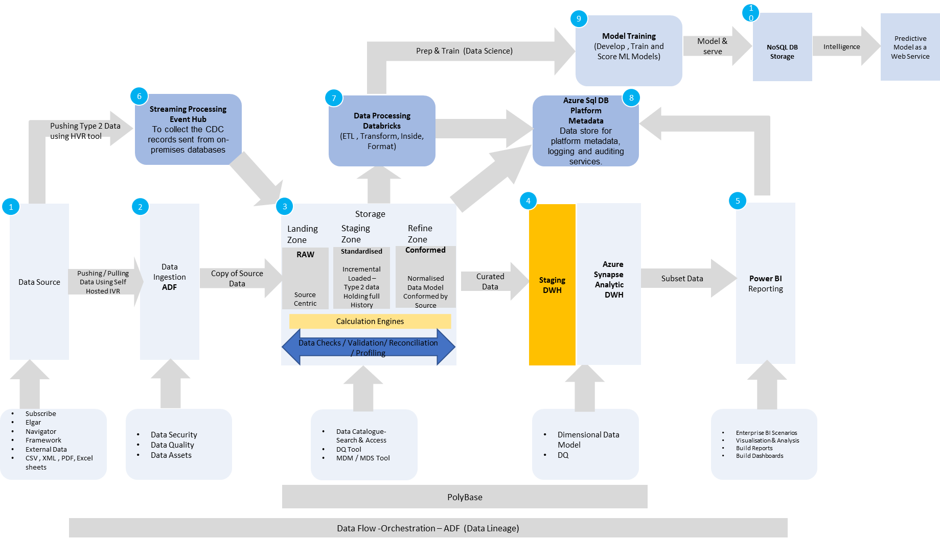

Component Overview
The following diagram breaks down the conceptual overview into the required environment components:
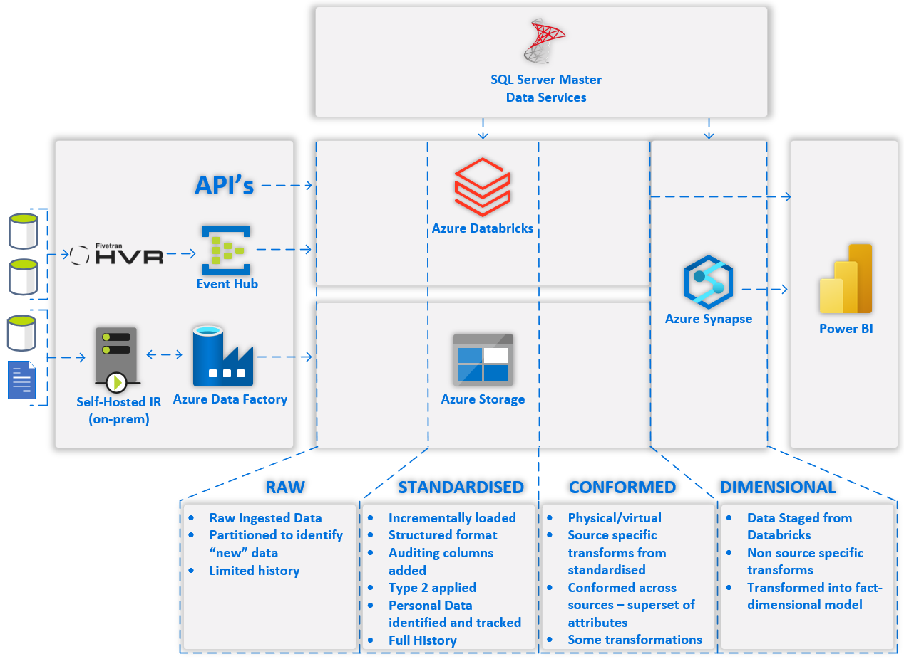

- CDC (Change Data Capture) represents the tool that will identify changes at the source and send those changes to the Event Hub
- The Event Hub is used to collect the CDC records sent from on-premises databases. It can also be configured for future integration with off premises 3rd party data.
- Integration Runtime is the Azure Data Factory Self-hosted integration runtime and is used to facilitate the pushing and pulling of data to and from the on-premises file shares or databases
- Azure Data Factory (ADF) is used to create the data pipelines between the Azure Storage, Databricks and the Data warehouse. It is also used to pull or push the data to the file shares on premise.
- Azure Databricks will be used to handle the ETL as well as utilizing the format the data will be stored in. Databricks notebooks will read data to and from the different zones during processing. The Databricks notebooks also will interact with the Azure SQL Database during processing as well as stage the data required for Synapse
- Azure Storage will be used to store the data in different zones to handle different security and processing needs. The access to the zones is controlled via access control lists (ACL) defined in Azure Active Directory. The high level zone types are:
  - Raw Zone is utilized to ingest data and identify changes
  - Standardised Zone handles full data history (Type 2), tracks PII and is incrementally loaded
  - Conformed Zone stores the conformed modelled data across sources, has data transformations and allows for physical and virtual storage

For more detail on the zones refer to later sections in this document.
- Azure SQL Database (ASQL) will be used to store the metadata defining the ETL process within the environment. In addition, the SQL database will be used to log the ETL execution information.
- Azure Synapse will be used to load the dimensional warehouse from the data staged from Databricks
- PowerBI is the access tool to be used by end users for interrogating the data as well as for generating reports.
- Data checks/validations and reconciliations can take place by sourcing data from any phase (Raw, Standarised & Conformed).

The high level To Be data landscape is presented in the diagram below.
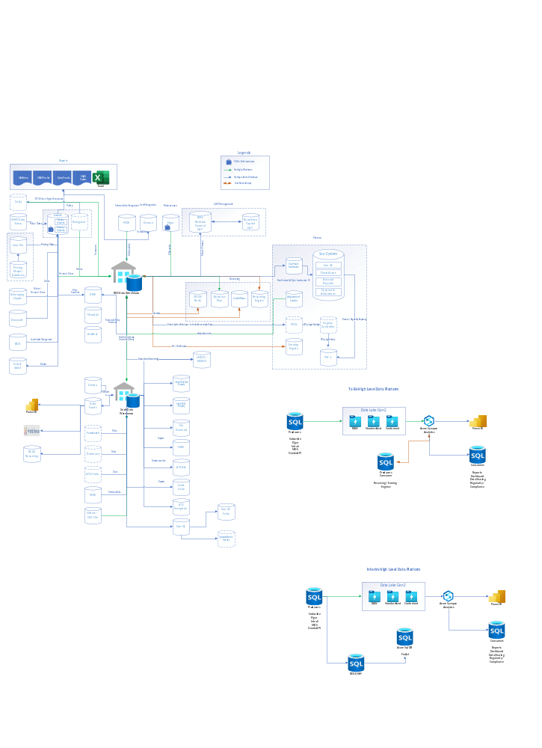

Data Architecture Process
Data architecture process refers to the systematic approach to designing, implementing, and managing the structure and integration of data in an organization. It involves creating a blueprint for how data will be collected, stored, processed, and used in an organization to meet its business objectives. To ensure that all data is considered by the data architecture process, the following guidelines and procedures can be established:
1. Establish clear scope and objectives: The first step is to establish clear scope and objectives for the data architecture process. Identify the scope of the process, the data sources that will be included, and the intended outcomes of the process.
2. Identify all data sources: The next step is to identify all the data sources that will be included in the data architecture process. This may include internal and external data sources, structured and unstructured data, and data from various departments within the organization.
3. Evaluate data quality: Before including any data source, it is essential to evaluate the quality of the data. This involves assessing data accuracy, completeness, consistency, and relevance.
4. Define data standards: To ensure that all data is considered consistently, it is essential to understand and define the data standards that all data sources must adhere to. This includes defining data formats, naming conventions, and metadata requirements.
5. Establish data governance: Data governance refers to the overall management of data within an organization. Establishing a data governance framework will help ensure that all data is considered during the data architecture process. This includes assigning data ownership, defining data policies, and establishing data quality controls.
6. Document data flows: Documenting data flows is essential to ensure that all data is considered during the data architecture process. This involves mapping the flow of data from its source to its destination, identifying any data transformations that occur along the way.
7. Use data modelling techniques: Data modelling techniques can be used to represent the structure and relationships between data entities. This can help ensure that all data is considered during the data architecture process.
8. Review and update regularly: Finally, it is essential to regularly review and update the data architecture process to ensure that it continues to consider all relevant data sources. This includes reviewing data quality, updating data standards, and incorporating new data sources as needed.
By following these guidelines and procedures, organizations can ensure that all data is considered during the data architecture process. This will help ensure that data is effectively managed and utilized to support business objectives.

Key Systems
DA at the enterprise level must consider all systems in use across Canopius however not all the systems currently live in Canopius are relevant to the Data Architecture of Data Platform, for different reasons: either they are not holding/ consuming any data from the data warehouse or they are support systems (like training platform, ServiceNow) which are not relevant from a data consolidation perspective. The key ones, that have been analyzed are presented in ..\Excel\Applications Catalogue.xls

Data Lake Storage
1. Data Lake Design: The data lake architecture should be designed to support data storage and processing for a wide variety of data types, including structured, semi-structured, and unstructured data.
2. Data Ingestion: The data ingestion process should be designed to support data ingestion from multiple sources, including batch and real-time data streams.
3. Data Governance: The data lake should be governed by a comprehensive data governance framework that includes data classification, data security, and data quality controls.
4. Data Storage: The data lake should use a scalable and flexible storage system that supports multiple storage options such as object storage, HDFS, and cloud storage.
5. Data Processing: The data lake should support a variety of data processing methods, including batch processing, stream processing, and interactive querying.
6. Data Analytics: The data lake should be designed to support a wide range of analytics tools, including data visualization, statistical analysis, and machine learning.
7. Data Access: The data lake should provide easy and secure access to data for authorized users, while ensuring that sensitive data is protected.
8. Data Retention: The data lake should comply with a data retention policy that defines how long data should be kept and how it should be archived or deleted.
9. Data Integration: The data lake should be designed to support data integration with other systems, including data warehouses, data marts, and external data sources.
10. Data Catalog: The data lake should have a comprehensive data catalog that provides metadata about the data stored in the data lake, including data structure, meaning, data lineage, data quality, and data access controls.
By following these principles and guidelines, data architecture can be designed for a data lake that supports efficient data flow and enables effective data analysis.

Data Lake Zones
The data lake storage has been spilt into number of zones, Each zone has its own characteristics, such as access control, retention policy, performance, and cost, which can be customized based on the requirements of the organization. By splitting the data lake storage into multiple zones, organizations can effectively manage their data, improve data quality, and optimize storage costs.

Raw Zone
The raw zone will be responsible to getting the data from the various sources and storing the data in as close to raw format as possible. It is intended for this area to be accessed only by ETL processes and support users for debugging purposes. Raw also contains the Databricks Delta Live Tables for CDC purposes, which behaves a little differently from the non-CDC raw tables. The Raw Zone will keep data for up to X rolling days. The data will be kept only for debugging and recovery purposes. Only the most recent data will be processed. A maintenance script will be scheduled to execute to remove tables that are past the retention date.

Standardised Zone
Standardised will contain the full history of data processed. Standardised still mirrors the data model of the source system. This will contain “Type 2” data of identified inserts, updates and deletes. All Data in the Standardised Zone will be stored in Azure Databricks delta format tables in Azure Storage. It is intended for this area to be accessed by the ETL processes and support users for debugging issues.

Conformed Zone
The conformed zone will be a normalized model It can also contain source-system-specific entities and attributes where that is appropriate
The conformed zone exists to allow the data to be modelled in a conformed fashion across sources.
It is intended that the conformed model will not have measures created in it, as those will be created as part of the dimensional model in the warehouse.

Dimensional Zone
Dimensional will be processed and held within Synapse dedicated pool and will be in the form of dimension and fact star schema structure. This will be the optimal structure for end user reporting. Transformations in stored procedures will take the data from the conformed shape to the fact dimension structure.

Role of Each layer In Data Platform

Source
Conformed
Warehouse
RAW
Standardised
- Source

- Source Centric
- Dumping ground
- History
- Metadata
- Standard format
- Conformed by Source
- Normalized Data Model
- Curated Data
- Source for DWH
- Augmenting / Standardizing / Transformation
- Data Science
- Abstract view of Source system
- Fact / Dimension
- Fast reporting
- High value
- Fully curated
- Marts
- No logic needed

Data Reconciliation Approach
The Data ingested on to the Data Platform from various source systems is processed, enhanced and validated at various layers within the Data Lake and Data Warehouse. Every Layer represents a transformation and implementation of Business logic

Source to RAW
This is the first step of Ingestion of data from any Heterogeneous Source (SQL Server Database, Warehouse, Excel Spreadsheets, Access DB, API fetched data) into the Data Lake. The data is retained as it is delivered from the Source without any transformations. The data checks at this layer include:
- Record Count Validation
- Field level data comparison between source and Target

RAW to Standardised
The data movement to Standardised layer enables the data from multiple sources to be streamlined in to a predefined standard format, which enables seamless processing of this input data in to further Data Lake layers without concerning about the Origin Source system of this data. E.g. one system may store date as dd-mmm-yyyy, while other may store it as dd:mm:yy:hh:mm:ss in Source and RAW layers, but it will be transformed it to a single agreed format at Standardized layer. The Data checks at this layer include:
- Record Count Validation
- Field level data comparison between source and Target
- Versioning of records using Type 2 SCD for the identified fields

Standardised to Conformed
Up to Standardised layer, all source data is treated in isolation with respect to its own source and version history tracking only. From Conformed layer onwards, the data from various sources are augmented and enhanced further by applying Business Logic and leveraging Master Data Management techniques. Most business logic is applied at this layer and data can be correlated to its own Business Domain (Claims, Underwriting, Settlement) irrespective of which system it is flowing from. This is the most refined data which can then be used for an end user function like Data Science, Business Reporting, Data Warehouse, etc. The key validation at this layer include
- Record Count Validation
- Field level data comparison between source and Target
- Data enrichment validation
- Data Augmentation validation
- Implementation of Business Logic

Conformed to Data Warehouse
The conformed data is stored further in the Warehouse layer where it corresponds to the DWH concept of Dimension, Fact, Bridge tables and Type 2 SCD is applied and Contras are maintained for every granular Business Transaction at Conformed layer. The key validation here include:
- Record Count Validation
- Referential integrity between data in Dimension and Fact (-1 for Unmapped data , -2 for undefined data)
- Contra generation and handling of deleted records

Data Movement
The movement of data between systems or data stores and the processes that perform the movement and associated transformations have a direct impact on the agility of the data. This agility can have a direct impact on the latency of business decision making i.e. the gap between data input and information availability. The Data Movement section is intended to define the detailed design of the processes focused on the extraction, transformation and load of data from the on and off premises sources.

This section will detail each phase of the ETL process and will be updated and revised as needed during the development phases of the project

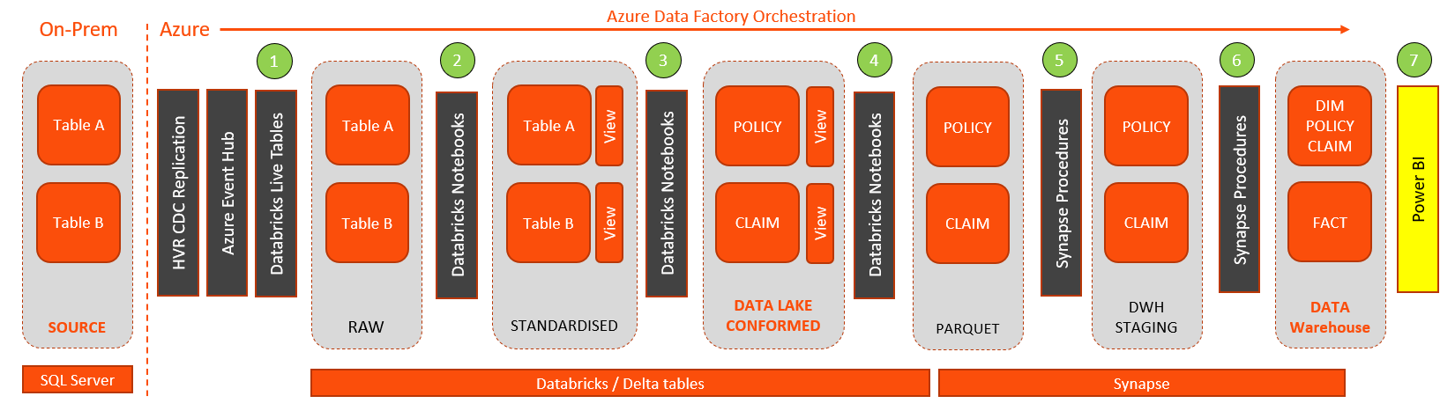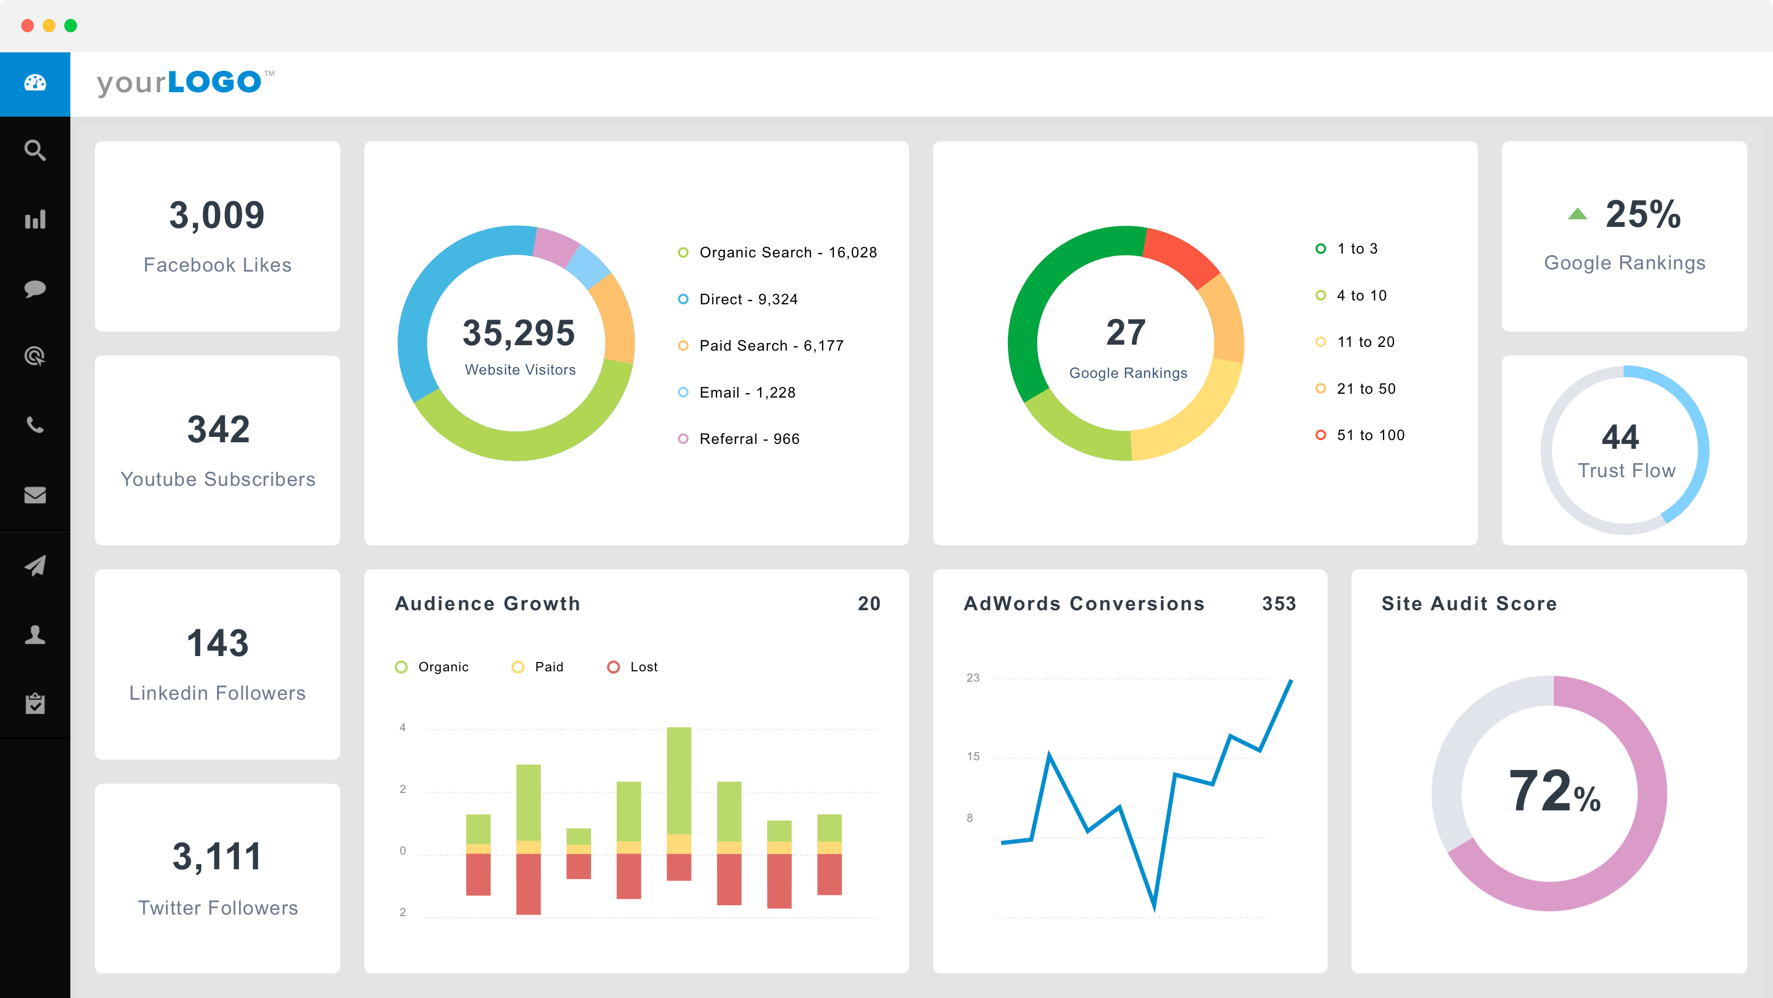
Source
Data Lake
DWH
Power BI

Extract From Source
- Source changes are replicated into Event Hub using HVR
- Event Hub streams data into Databricks delta Live tables
- Stored as a single delta table per source
- There is a single row in the table per change in the source system as sent from HVR. The actual message is stored in a single column in the table as a “nested structure” – example here

Load into Standardised
- Generic (Metadata Driven) Databricks Notebook
- Standard Metadata Added / Type 2 Changes Tracked
- Minimal Data Transformation (copy of source format)
- Stored in Azure Databricks Delta table

Transform and Load to Data Lake
- Databricks Notebooks for ETL process
- Data is fully transformed into conformed model
- Stored as Delta tables per source
- Conformed views present single view across sources.

Extract to Incremental Parquet
- Incremental changes are extracted into Parquet files
- Data read from Conformed views
- Process run through Databricks notebooks
- No data transformation

Load to Data Warehouse Staging
- Parquet files mounted as Synapse External Tables
- Synapse Stored Procedures load into DWH staging tables
- Type 2 applied – staging table should match the conformed view

Transform and Load to Data Warehouse
- Synapse Stored Procedures load into Data Warehouse
- Data is fully transformed into Fact / Dimensional model.

ETL Phases
- Source to Raw
- Raw to Standardised
- Standardised to Conformed
- Conformed to Staging
- Staging to Synapse

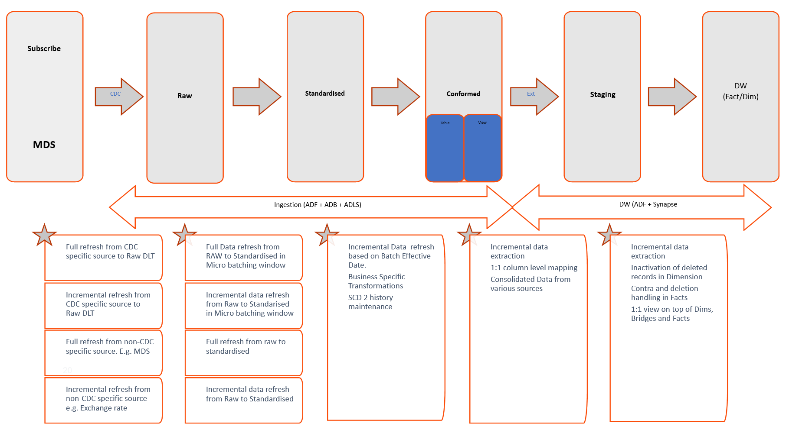

High Level Design – EventHub to Raw DLT

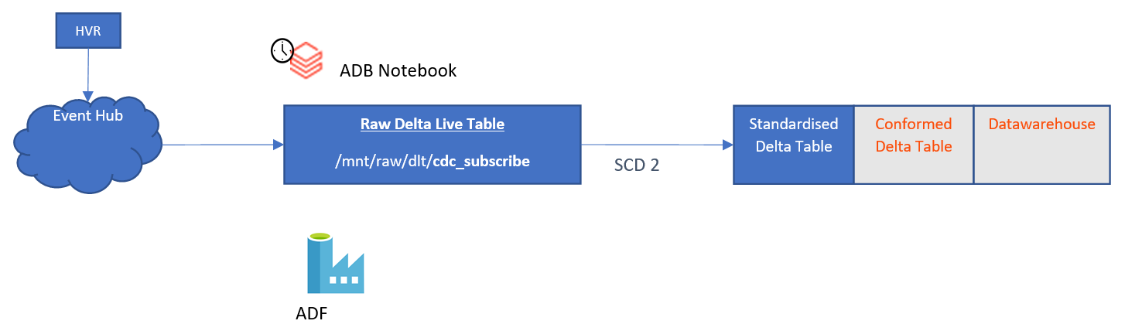

- HVR is implemented for CDC solution, HVR will capture the change data from Transactional logs of Source systems and then HVR routes the data to Event hub and Event Hub streams data into Raw Databricks delta Live tables.
- Azure EventHub streams the data into Databricks Delta Live tables and load the data into Standardised through micro batching window.
- Databricks pull data from EventHub and will process directly into the raw delta live table for downstream consumption.

Data Flow without CDC from Source to RAW
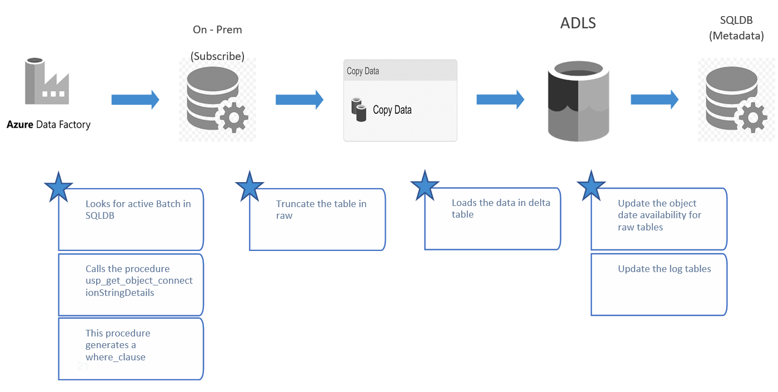

Data Flow with CDC from Source to RAW
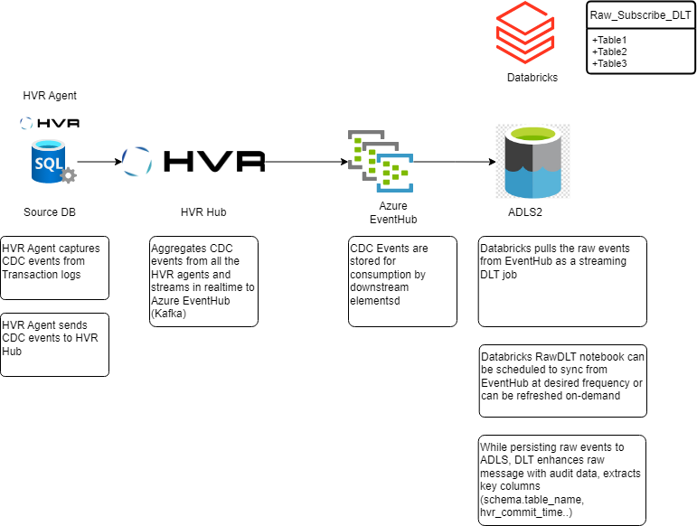

Raw to Standardised
Data get loaded into Standarised using based on Standardised threshold in micro batching window , there is no transformation only ‘default’ flow being 1:1 mapping.
The Raw delta table will hold ALL messages that arrive from HVR, which could potentially include multiple rapid changes to the same source record. we only need to take the latest version of that record within the batch window. Considering the possible final operation by PK on a case-by-case basis, we see that:
- For an INSERT, in the vast majority of cases this will be the only operation in the batch. There is an edge case in which a PK value was deleted then re-inserted in the same batch (potentially with different attribute values) but our downstream process will correctly handle this as an update
- For an UPDATE or REFRESH, the HVR message contains the latest values of all attributes of the record, so earlier messages are not required to fully understand the current state
- For a DELETE, earlier operations in the batch are irrelevant as the record no longer exists
So, we can safely discard all messages for a given PK value other than the latest within the batch. We can now construct temporary table with new / updated records to be reflected in Standardised and process this temporary table into the corresponding Type 2 history-tracked Standardised layer table.

The behavior of the Raw to Standardised load differs when the batch contains a full refresh of the table, we must carry out a full comparison of source and target tables to identify PK values that have been silently dropped from source but still exist in our target table.

Without CDC from Raw to Standardised

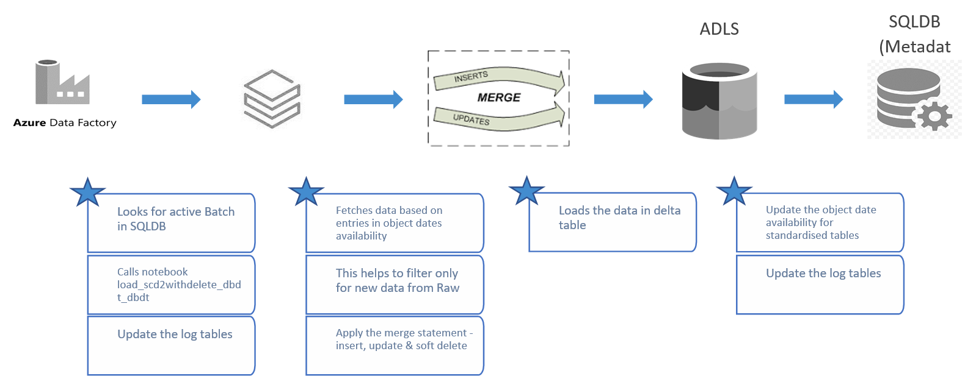

With CDC from Raw to Standardised
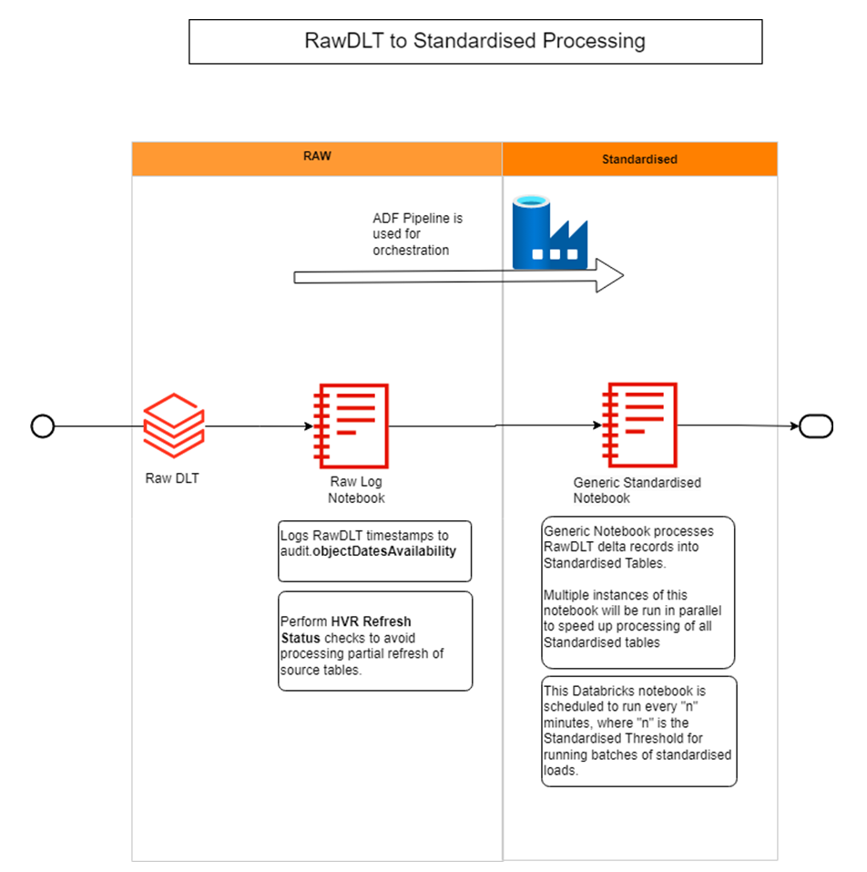

Standardised to Conformed

Data is extracted from Standardised table in batches as per the Batch Effective Date using azure databricks for transformation logics. It helps us to load the data “as is” for a particular timestamp, however, we can only load BED sequentially. As we have concept of soft deletion of record happening in Standardised table the SCD logic needs to include “lakeDeletedTimestamp” for handling the updates.

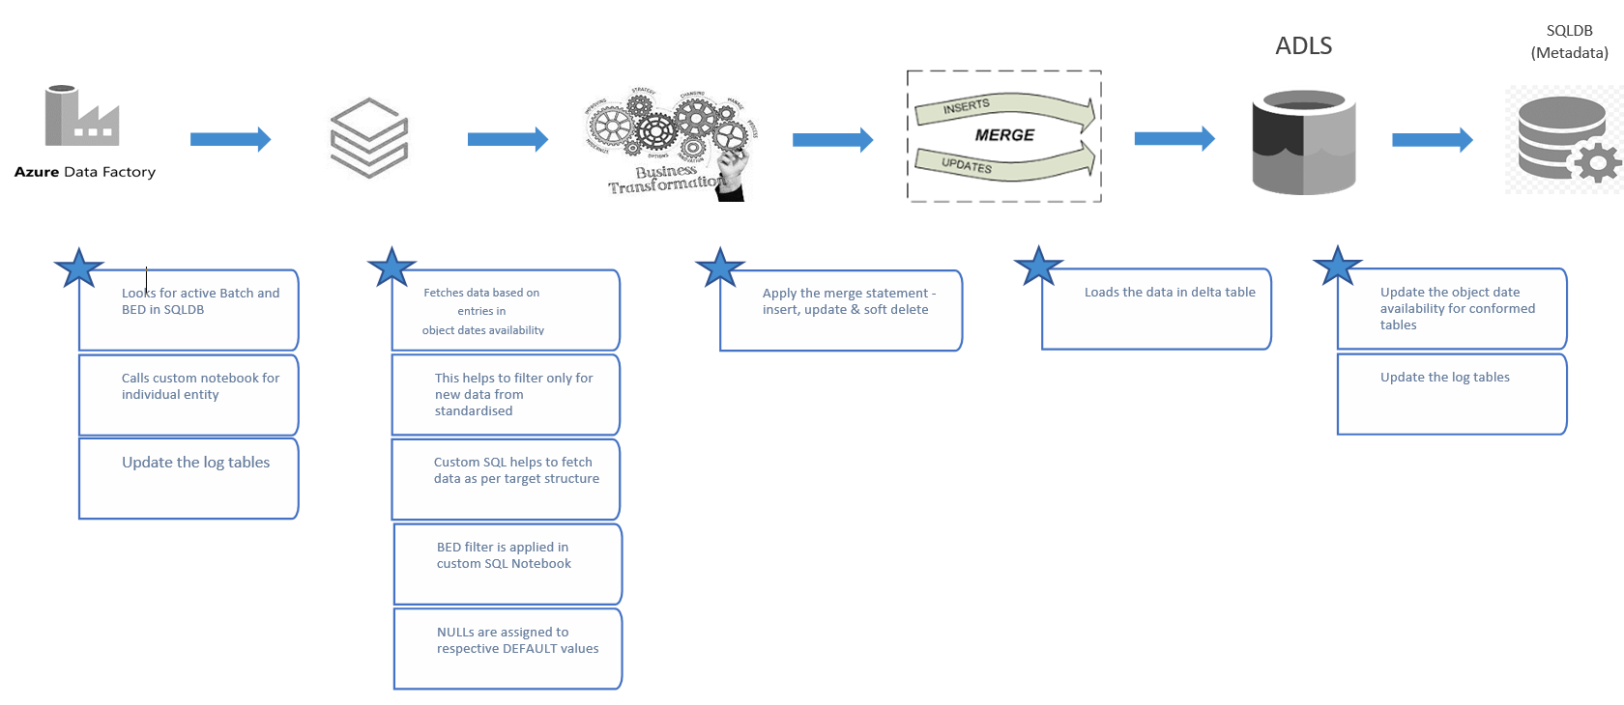

The following simplified diagram illustrates suppression of multiple rapid changes to a record during a batch while loading from Standardised to Conformed

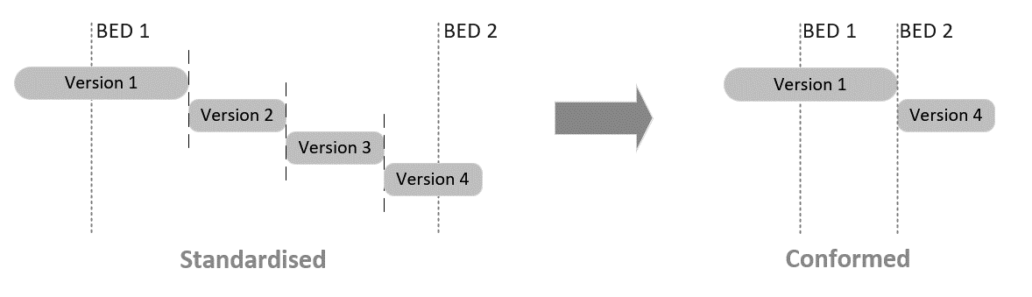

The essence of the BED approach can be captured as follows:

- Incremental loads will be conducted in batches during which a clearly-defined window of data will be processed to Conformed. There can be multiple such batches processed per day. Each batch has an associated “Batch Effective Date”, which is the latest time considered during processing of that batch
- Within a batch, if the same source record is updated multiple times, only the latest version of that record will be processed to Conformed
- All records created/updated/deleted in Conformed as a result of the batch will receive ValidFrom / ValidTo timestamps equal to the BED of that batch.
- Multiple updates to the same entity occurring within a batch are handled as individual Type 2 changes within Standardised – no change resolution is suppressed. ValidFrom/To fields in Standardised match timestamps of CDC records (once CDC is in place).
- Once the batch has loaded relevant data to Standardised, it also loads through to Conformed, but taking only records current at the batch effective date point. Intra-batch changes prior to final record state are ignored.
- All new/updated records in Conformed as a result of the batch receive ValidFrom/To values equal to BED.

As well as pushing new and updated records from source systems through to the data platform for processing, the CDC component will also capture deleted source records.
- When processing deleted records, it is not sufficient for the data platform to simply physically delete corresponding data from the lake and warehouse; these must instead be handled as “soft deletes” with an appropriate context of time, in the same way that updated records are tracked through Type 2 changes via ValidFrom and ValidTo timestamps.
However, if a record is deleted instead of updated, the latest type 2 version of that record in Standardised will be closed-off and receive a ValidTo timestamp less than the BED, In this case, the standard BED logic will find no current version of the record valid as per the BED and so will pull no version of this record through to Conformed - the deletion is “lost”:

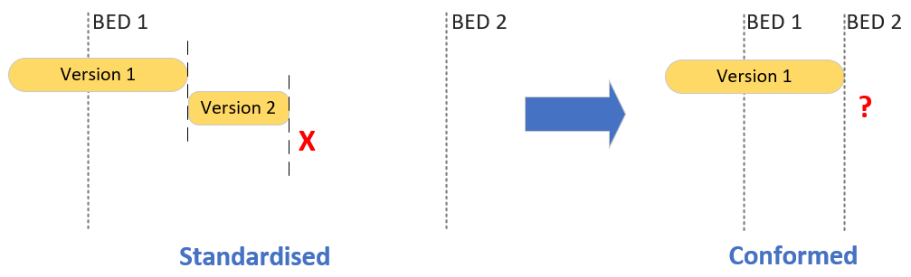

Conformed to Staging
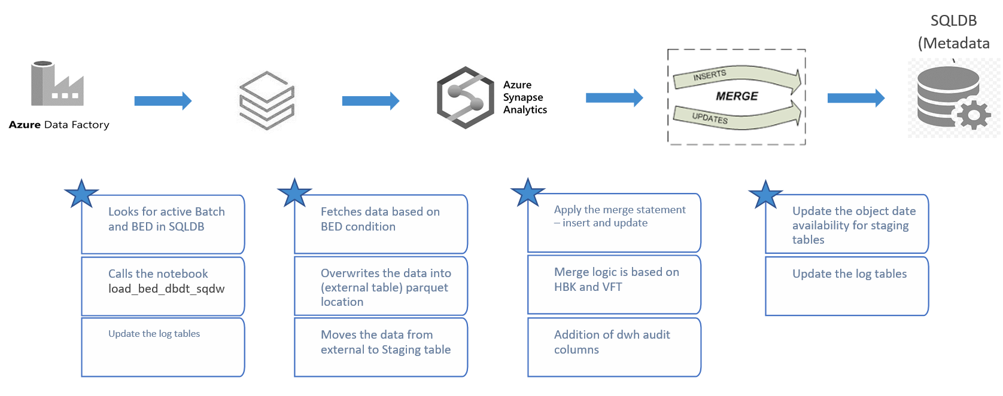

Staging to DW
This layer hold the fact, dimension and bridge tables of the warehouse. It includes addition of surrogate keys along with business specific transformations. Data gets loaded using incremental load in the DW tables.
One major change here is that, the records marked as deleted are treated as active records till staging layer but in DW layer those records gets updated and are treated as an inactive.

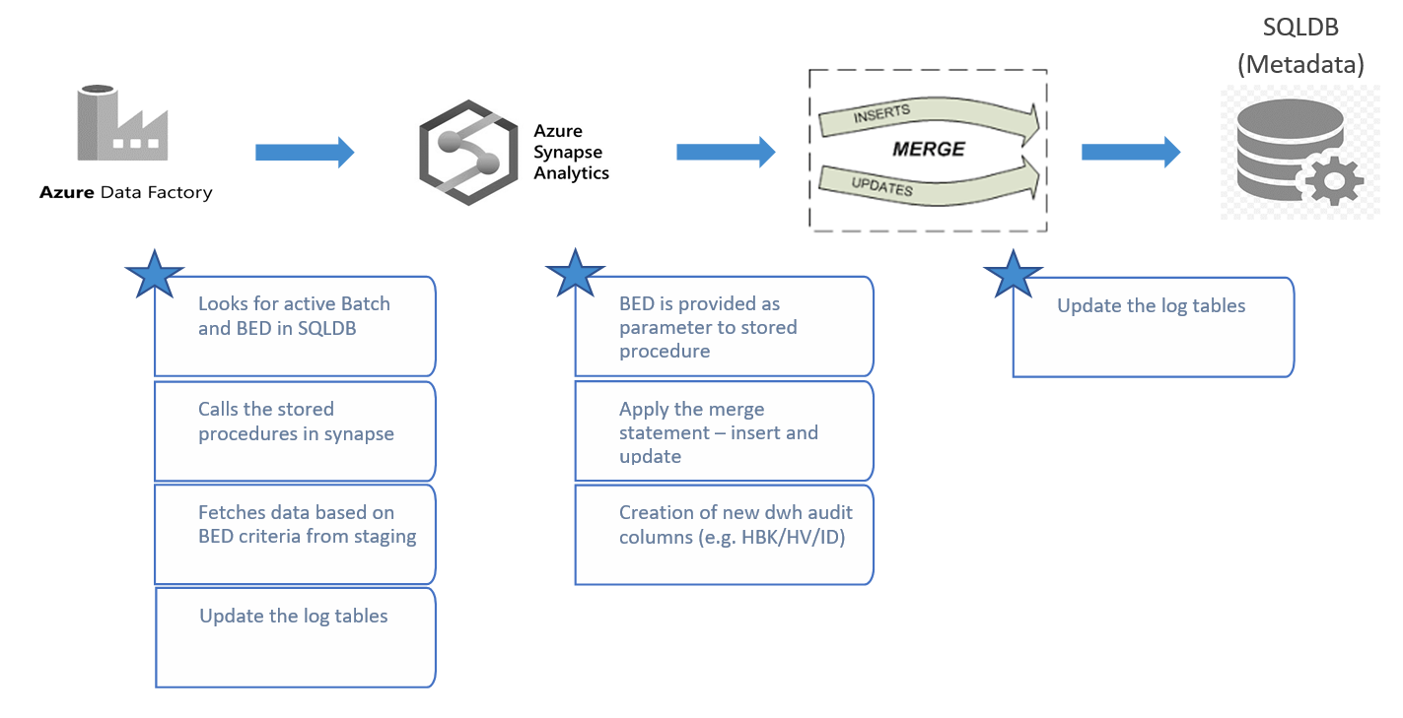

Data Integration
It is a critical component of a data lake architecture as it enables data to be brought into the data lake from various sources, integrated and made available for analysis. Also it is essential for ensuring that data is shared effectively across the organization. This involves defining the integration technologies, protocols, and processes that will enable data to be shared seamlessly between different systems and applications. Here are some principles and guidelines for data integration in data lake zones.

1. Define clear data integration objectives: Before embarking on a data integration project, it is essential to define clear objectives that align with the business goals and requirements. This ensures that the data integration effort is focused and has a measurable impact on the business.
2. Identify data sources: Identify the sources of data that need to be integrated into the data lake, including structured, semi-structured, and unstructured data.
3. Define data integration processes: Develop processes for extracting, transforming, and loading (ETL) the data into the data lake. These processes should be designed to ensure that the data is accurate, consistent, and complete.
4. Establish data governance policies: Data governance policies should be established to ensure that the data is properly managed, secured, and compliant with regulatory requirements.
5. Apply data quality controls: Data quality controls should be implemented to ensure that the data is accurate, consistent, and complete. This includes validating the data during the ETL process and applying data profiling and cleansing and standardizing techniques.
6. Leverage metadata: Metadata is crucial for data integration in a data lake. It provides a common understanding of the data structure, its meaning, and its lineage, making it easier to integrate and analyse. (Metadata guidelines Keith documented somewhere ?)
7. Implement data lineage: Data lineage enables the tracking of the data from its source to its destination in the data lake. This is important for data governance, compliance, data quality issue analysis and auditing purposes.
8. Use scalable and flexible integration technologies: The data integration technologies used should be scalable and flexible to handle the large volumes and variety of data in a data lake. This includes technologies such as Data factory , Databricks , EventHub etc.
By following these principles and guidelines, organizations can establish a robust data integration process in their data lake zones that delivers high-quality, integrated data for analysis and decision-making.

Integrating new system / Data into New data platform
Scope and non-functional requirements:
- Which tables/elements from the source system will be required? If in doubt, the principle of a data lake should be the ALL data is brought through, however scope may be deliberately restricted for various business reasons
- What level of historic information is required for the new system within the data platform? Should all ongoing changes be tracked with Type 2 changes for all tables/columns? Is a one-off historic load (followed by ongoing incremental loads) required? Do any special rules need to be applied to the one-off load e.g. for recalculation of historic accounting periods?
- What are the refresh requirements for this new source (intra-day, daily, weekly, monthly etc)?
- Does the source contain personal/sensitive data? If so are there special requirements around how this should be handled?
- Are there any additional security requirements relating to this new data that would need to be reflected in any/all layers of the data platform? Or any requirements relating to data retention etc?

Solution Architecture / data ingestion:
- Through what technical process should data from the new system be ingested into the data platform? E.g. will HVR be implemented at source to allow CDC changes through the existing Event Hub -> DLT method? Or will some other form of connectivity to the source be required, and if so will this mandate full refreshes or CDC-style incremental loading?
- Will this ingestion approach be able to reuse existing ADF pipelines/CDC components/landing zones etc already in place within the data platform, or will new components be required (which may require additional design or PoC work)?
- Will ingestion of the new source required any infrastructure changes within Azure e.g. opening new firewall ports etc?
- The normal ingestion method is to ingest sources into Raw, then Standardised, then Conformed, then Dimensional – sequentially. Although this is likely to be the appropriate approach in almost all cases, it should be considered case-by-case whether ingesting directly to a higher layer is more appropriate.

Modelling:
- Once scope is agreed, (Raw and) Standardised models of the source system can be produced, to allow ingestion of the new source into the early layers of the data lake
- The source should then be mapped into the Conformed model. If the new source is a new instance of a source system type already present in the platform (e.g. a new Underwriting system) then the Conformed model may only need minor (or even no) enhancements to accommodate the new data. For other sources, a considerable number of number tables and relationships may need to be modelled, as per platform standards, for this system.
- Consideration should be paid to whether new the source contains data elements mastered within the existing data platform MDS instance, and also whether there are any new MDS entities that should be implemented from this source.
- Once the Conformed model has been extended to accommodate the new source, the dimensional Warehouse model can similarly be addressed
- Finally, consideration needs to be given to reporting views and any further downstream layers (where possible, known reporting requirements should be taken into account during development of the dimensional layer)

Development can then proceed to implement the above.

Considerations for feeding data from the data platform to other systems:
- Is the downstream use more suited to the normalised Conformed layer, or the dimension Warehouse layer? It is possible to access/extract data from either of these layers depending on use case. Pre-canned reports or direct access by non-technical business users will typically be best against the demoralised Warehouse where it is not necessary to understand and consider multiple table joins etc. Fine-grained access with less latency/processing applied by power users (or to feed other forms of data science/reporting system) may be better direct against the Conformed layer.
- Is the intended data access a push or a pull? If it’s a push, with what frequency should this be carried out, and what volumes of data will be involved. How important is the timeliness of the delivery e.g. can this wait if a Conformed load is ongoing at the scheduled export time? If it’s a pull, then will this be done on a fixed schedule or ad hoc, and will the content of the pull be defined in advance or could it vary ad hoc?
- Are there security/sensitivity concerns that need to be applied? E.g. if granting ad hoc access to a group of users, how should this access appropriately be restricted
- Technical implementation – what is the most appropriate way to achieve the push/pull (which will depend on requirements around the content, size, frequency and reliability of the extract as well as anything dictated by the physical nature of the downstream system/tool)? Is this likely to place any significant burden on the data platform itself in terms of performance degradation/interference with loads?

